**Software requirement**

**Specification**

**for**

**Home application**

**Version 1.0 approved**

**Prepared by Dao Quoc Trung**

**27/02/2021**

**Table of Contents**

**Table of Contents**

**Revision History 2**

1. **Introduction**

1.1 Purpose 3

1.2 Project Scope 3

1.3 Intended Audience and Reading Suggestions 3

1.4 Document Conventions 3

1. **Overall Description**

2.1 Use case Diagram 4

1. **System Feature**

3.1 System Feature 1 5

3.2 System Feature 2 6

3.3 System Feature 3 6

3.4 System Feature 4 7

3.5 System Feature 5 8

3.6 System Feature 6 10

3.7 System Feature 7 10

3.8 System Feature 8 11

**Revision History**

|  |  |  |  |
| --- | --- | --- | --- |
| Name | Date | Reason to change | Version |
| Trung | 28/02/2021 | Initialize document | 1.0 |

1. **Introduction**
   1. **Purpose**

The purpose of this document is to provide a complete and accurate description of the requirements for the Home application. This document can be used as input for the design and testing of the Home app

* 1. **Project Scope**

This document defines a requirement to develop FUNiX’s Home application

* 1. **Intended Audience and Reading Suggestions**
* Developer
* Tester
* FUNiX
  1. **Document Conventions**
* SRS: Software Requirement Specification
* SW: Software

1. **Overall Description**
   1. **Use case Diagram**

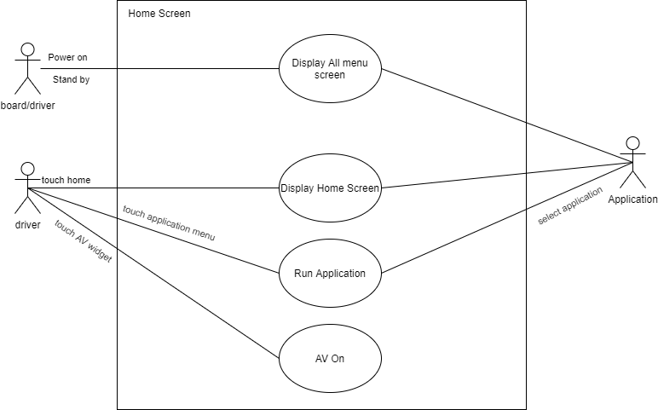

1. **System Feature**
   1. **System Feature 1**

|  |  |
| --- | --- |
|  | **Description** |
| **Goal** | Provide layout in home screen |
| **Actor** | User |
| **Event** | Power on |
| **Requirement** | **Home_SRS_01.1** Home Screen has 3 display are    **Home_SRS_01.2** Statusbar area. Display information about status(time,…)  **Home_SRS_01.3** Widget area. Display information of other application via widgets (media, climate, map)  **Home_SRS_01.4** Application area menu. This area is displayed in listview format for the application |

* 1. **System Feature 2**

|  |  |
| --- | --- |
|  | **Description** |
| **Goal** | Describe the interaction on the screen |
| **Actor** | User |
| **Event** | Touch |
| **Requirement** | **Home_SRS_02.1** Displays the applications in the system store in xml file  **Home_SRS_02.2** The displayed list can be scrolled  **Home_SRS_02.3** Display information of an application including title, icon of the application  **Home_SRS_02.4** when app is selected, show focus image and only one focus image is available at the time  **Home_SRS_02.5** when app is opened, the screen  have button back to comeback home screen  Non-functional requirements:  **Home_SRS_02.5** Time for displaying application list < 2s after starting Home application  **Home_SRS_02.6** The applications displayed in the menu need to be stored and read from an xml file for user to easily edit and delete |

* 1. **System Feature 3**

|  |  |
| --- | --- |
|  | **Description** |
| **Goal** | Show information in status bar |
| **Actor** | User |
| **Event** | Power on |
| **Requirement** | **Home_SRS_03.1** Displays clock time based on 24 hour system. Second are not given. Time segments is “HH:MM”. It in center at status bar  **Home_SRS_03.2** Displays date of month with format “dd:MM” at center at status bar  **HOME_SRS_03.3** Displays signal strength in mobile phone network  **HOME_SRS_03.4** Displays connected to wi-fi network  **HOME_SRS_03.5** Expect clock time and date, all icon will show at right side of status bar |

* 1. **System Feature 4**

|  |  |
| --- | --- |
|  | **Description** |
| **Goal** | Show media app via widget |
| **Actor** | User |
| **Event** | Power on, Click on |
| **Requirement** | **HOME_SRS_04.1** Show title of widget  **HOME_SRS_04.2** Displays name of song and singers  **HOME_SRS_04.3** Displays playback time in the process bar  **HOME_SRS_04.4** Background of widget shows album art cover  **HOME_SRS_04.5** Displays album art cover as icon in the widget  **HOME_SRS_04.6** when click, run media application |

* 1. **System Feature 5**

|  |  |
| --- | --- |
|  | **Description** |
| **Goal** | Show climate app via widget |
| **Actor** | User |
| **Event** | Power on, Click on |
| **Requirement** | **HOME_SRS_05.1** Displays information of widget  **HOME_SRS_05.2** Displays driver and passenger text and icon  **HOME_SRS_05.3** Displays the wind direction of driver and passenger by icon  **HOME_SRS_05.4** Displays the temperature outside of car  **HOME_SRS_05.5** Displays the temperature inside of car  **HOME_SRS_05.6** if the temperature is lower than 16℃, displays “Low” and it’s higher then 27.5℃, displays “High”    **HOME_SRS_05.7** Displays the status of auto is on or off by icon  **HOME_SRS_05.8** Displays the status of sync is on or off by icon  **HOME_SRS_05.9** Displays the fan and the intensity of fan by icon  **HOME_SRS_05.10** When click on app , run application |

* 1. **System Feature 6**

|  |  |
| --- | --- |
|  | **Description** |
| **Goal** | Show media app via widget |
| **Actor** | User |
| **Event** | Power on, Click on |
| **Requirement** | **HOME_SRS_06.1** Displays the position of the vehicle on map in real time  **HOME_SRS_06.2** When click on app, run that application |

* 1. **System Feature 7**

|  |  |
| --- | --- |
|  | **Description** |
| **Goal** | Describe Application layout |
| **Actor** | User |
| **Event** | Power on |
| **Requirement** | **Home_SRS_07.1** The displayed list can be scrolled  **Home_SRS_07.2** The application list is displayed right after starting the Home application  **Home_SRS_07.3** Can display up to 6 applications at the time  **HOME_SRS_07.4** Expect clock time and date, all icon will show at right side of status bar |

* 1. **System Feature 8**

|  |  |
| --- | --- |
|  | **Description** |
| **Goal** | Show other app via application layout |
| **Actor** | User |
| **Event** | Power on, Click on |
| **Requirement** | **HOME_SRS_08.1** Displays name of app  **HOME_SRS_08.2** Displays icon of app  **HOME_SRS_08.3** When click on app, run that application |